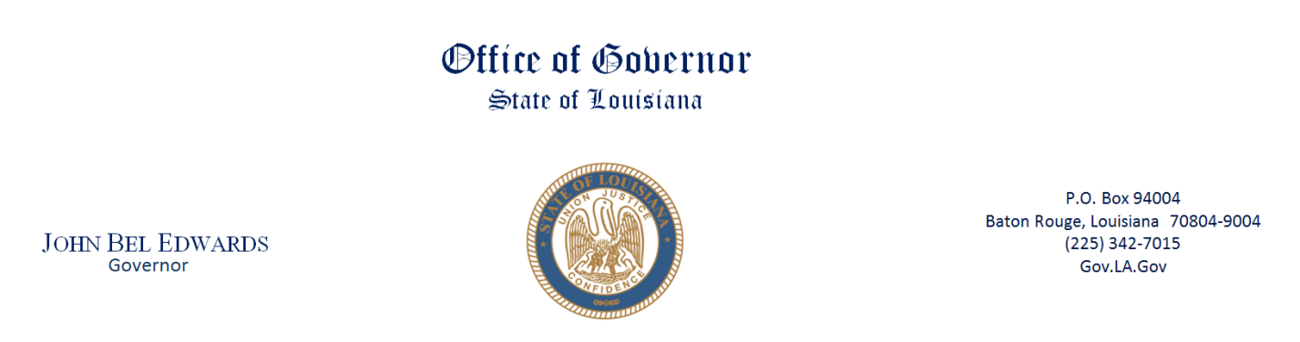

Public Meeting Notice

Council on the Children of Incarcerated Parents and Caregivers
December 7, 2023
10:00am – 12:00pm
Governor’s Press Room, 4th Floor

- Welcome/Call meeting to order Dominque Jones-Johnson, CIP Chair
- Roll Call Dominque Jones-Johnson, CIP Chair
- Presentation Dr. Shayla Polk, PhD,
Assistant Director Drug Policy
- Presentation Mrs. Angelic Keller, Esq.
Office of Juvenile Justice
- Discuss upcoming events All council & and committee members
- Next Steps Dominque Jones-Johnson CIP Chair
- Public Comment
- Adjournment

YOUTUBE LIVE STREAM: https://www.youtube.com/channel/UCNcGodSlBUhLcOmotMk7OEw/featured

